- Arm Blending | Teacher says a simple 3 letter word in sound talk, e.g. c-o-t. The teacher touches the shoulder for the first letter, the elbow for the middle letter, and the hand for the final letter. Can children guess what the word is? When they guess it they say the word all in one go by brushing their arm smoothly from the shoulder to the hand.  Games to Support Jolly Phonics
- Counting Sounds | Teacher says a word. Children say the sounds in the word, holding up a finger for each sound. Example 1: Teacher says: “big”, Children say “b – i – g “, holding up a finger for each sound so that they end up holding up 3 fingers.  Example 2: Teacher says “ship”, children say “sh – i - p” , holding up a finger for each sound so that they end up holding up 3 fingers.
- Ask my friend the sound | After teacher has dictated some sounds children point to the sounds they have written and ask their friend to say the sound
- Consonant blending with arm | Write a range of consonant blends on the board (e.g. cl, pr,st,gr). Point to each one. Can they say the sounds slowly and then quickly? e.g.  “c…l cl, p…..r pr, s….t st g…r gr” Use arm
- Count the consonant blend | Teacher or puppet says initial or final consonant blend quickly. Can children hear the sounds in the blend and say them slowly?  e.g. Teacher: “pr “ Pupil: “p…..r” , Teacher : “fl” Pupil: “f….l” use fingers
- Choose the correct sound | Teacher or puppet says a word (e.g. sit) the children have to choose the correct sounds from the flashcards laid out on a desk and put them in the correct order to make the word.
- Silent blending | Teacher writes letters on the board and points to the letters one by one to make a word. The children have to blend it in their head and put their hand up when they know the word.
- Hula Hoop | Use 2 or 3 sounds at a time, mystery bag, with items of sounds to be sorted.  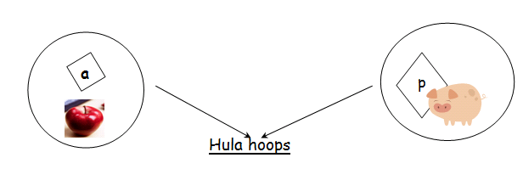 Thanks to Kemi Adebayo
- Sound song | This is the way we learn our sounds  learn our sounds x2  This is the way we learn our sounds,  come and learn with me. Thanks to Kemi Adebayo
Game 10. Finished!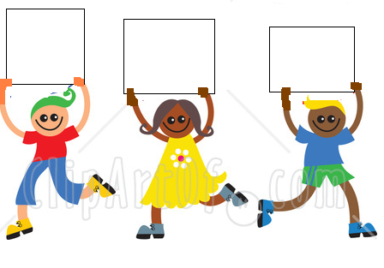Teacher calls out a word such as the ones at the top of the table below. She/he gives children the letters they need to make the words in the game. Children who have the letters needed to make the word come to the front of the class to make the word. Once the word is made the teacher calls out the next word. One child will have to sit down and a new child with the correct letter will have to come up to make the new word. Once the children return to the 1st word they shout “Finished!”
h
o
p
Simple sounds and diagraphs | Consonant blends at the end | Consonant blends at the beginning
Give out cards: s,a,t,p,i | Give out cards: s,a,t,p,i,n, | Give out cards: p,t,d,m,s,o,a
sat | pin | pot
sit | pit | pod
sip | sit | pad
tip | sat | sad
tap | pat | mad
sap | pan | mat
sat | pin | pat

Only do the ones below if children know the sounds on the cards you give out!
Simple sounds and diagraphs | Consonant blends at the end | Consonant blends at the beginning
Give out cards: h,o,p,y,sh,i,n,a, and m | Give out cards: sh,ch,th,ng,p,n,r,c,a,i | Give out cards:  ar,ai,oo,oa,c,d,l,m,n,t
hop | Ship | car
top | Chip | card
shop | Chin | lard
ship | Thin | laid
tip | Than | maid
nip | Can | mood
nap | Cash | moon
map | Rash | moan
mop | Rang | moat
hop | Ring | mart
 | Rip | cart
 | ship | car

