Preschool Professional Course
Activity Sheet of STEM/STEAM Lesson 1 (Part 1)
S

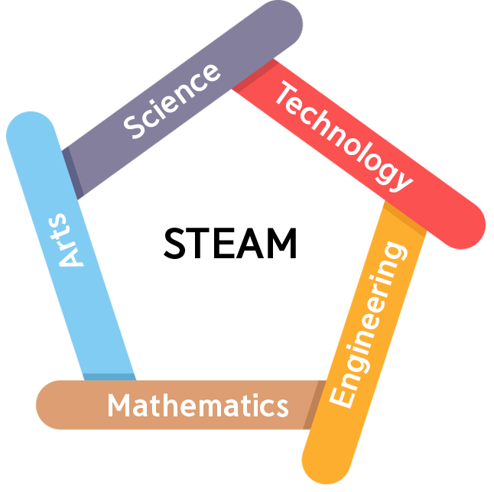

What exactly is STEAM?
STEAM stands for Science, Technology, Engineering, Arts, and Mathematics, and it is an integrated approach to learning that guides student inquiry and critical thinking. STEAM develops critical 21st-century abilities, such as taking calculated risks, engaging in experiential learning, being tenacious problem solvers, and excellent communicators, as well as strong creative design talents.
STEAM is typically project-based, and it employs a variety of instructional methods to involve students in hands-on "real-world" problem solving for more realistic learning. STEAM is a combination of teaching techniques, content, abilities, and attitudes that helps students build key transferable skills and learning across topics by allowing them to explore, try things out, and be creative.

Preschool Professional Course
Activity Sheet of STEM/STEAM Lesson 1 (Part 1)

In this project, you must come up with one object that may be built out of recycled materials and that is useful.

- What do I have to do?

- How will I do it?

Preschool Professional Course
Activity Sheet of STEM/STEAM Lesson 1 (Part 1)

- What materials will I need?

Crete a Plan!
Use this space below to draw a diagram or explain your plan.

