Preschool Professional Course
Activity Sheet of STEM/STEAM Lesson 2 (Part 2)

S

Paper Ball Run Challenge
Abstract:
You'll make a ball run out of paper and tape in this engineering challenge, but there's a catch! You want your ball to move as slowly as possible. How long do you think the ball will take to travel from the entrance to the exit?

- This project can be used to investigate a variety of physics and engineering subjects.

Terms and Concepts
- Kinematics
- Distance
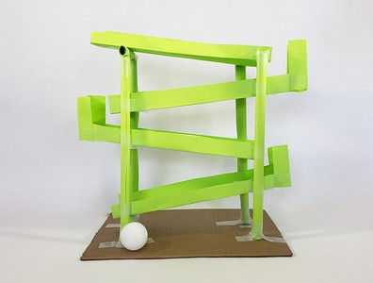
- Time
- Velocity
- Energy
- Gravitational potential energy
- Kinetic energy
- Friction
- Thermal energy
- Acoustic energy
- Simple machine
- Lever
- Inclined plane
- Wheel and axle
- Beam
- Truss
- Engineering design process
- Iteration
Questions:
- How can you make a simple ball run out of paper and tape?
- How do you make the ball travel slower or take longer through the ball run?

Preschool Professional Course
Activity Sheet of STEM/STEAM Lesson 2 (Part 2)

Supplies and equipment
Materials for construction
- A piece of paper (maximum 30 sheets). The use of printer, construction, graph, and notebook paper is permitted (letter or A4 size; 9" x 12" or 22 x 30-cm construction paper also allowed). Newspaper and cardstock are not permitted.
- Tape, maximum 1" (2.5 cm) wide (maximum one roll). Masking tape, painter's tape, and clear office tape (e.g. Scotch®) are all permitted. Duct tape, double-sided tape, and packing tape are not permitted.
- A flat surface such as the floor, a table, or a counter.
Tools:
- Ruler
- Pencil
- Stopwatch
- A ping pong ball, also known as a table tennis ball, is a small ball that is used to play table tennis (1)\
