Preschool Professional Course
Activity Sheet of STEM/STEAM Lesson 3 (Part 2)

S

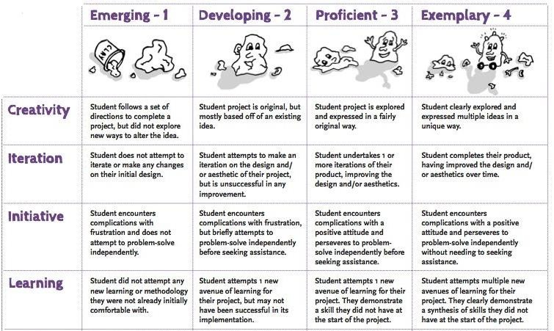
Classroom evaluations using rubric

Rubrics are a helpful tool that teachers can use to grade student work using an objective, fair assessment. The rubrics are a useful assessment tool for project-based learning implementations because they give a thorough understanding of a student's entire learning and skill-building process that takes place during project-building and take into account the real-world skills of collaboration, problem solving, and communication.

The desired outcomes for student assignments are outlined in a rubric. A rubric includes:

1. Particular performance standards that will be used to evaluate students.
2. Clearly defined performance ladders or levels.

The use of a rubric assessment tool makes it easier to communicate the standards for excellent performance, making it the ideal tool for student self-evaluation. It also gives students and teachers the chance to have a discussion about producing work of the highest caliber.
What exactly is a rubric?

The elements that will be evaluated, the performance levels, the performance criteria that specify the levels, and the score are all included in a rubric. The table below contains the learning performance and project requirements
The Performance Criteria lists the performance areas on which students will be graded on.
Performance Criteria | Below Standard  (1 Point) | Approaching Standard  (2 Points) | At Standard  (3 Points) | Score
Levels of performance are listed on the top portion of the table, it shows the corresponding score per level.

The scoring measure for each performance criteria is defined in this section of the rubric.
Where the final performance score for each performance criteria is written

Designing a Rubric

Starting with the end in mind is just as crucial when designing a student project. What sort of performance is you interested in seeing? Then, as students finish a solution or product to complete the task, clearly specify how they should demonstrate each performance criterion. To enable a more precise, detailed, and practical authentic assessment, create a rubric for the finished output and the numerous project work components.

A rubric is a reliable method for evaluation that:

• Specifies the precise requirements for a project.
• Looks at both the finished product and the complete project development process.
• Lists the performance standards by which students will be judged.
• Describes the evaluation criteria for each performance level.
• Assists kids in comprehending the standards they must reach to succeed.
• Prevents subjectivity, bias, and ambiguity in the evaluation process.

Example of Rubrics
Performance Criteria | Below Standard (1 Point) | Approaching Standard (2 Points) | At Standard (3 Points)
Developing and Revising Ideas | I still need to learn how to identify the reasons and evidence an author or speaker uses to support a point.  I still need to learn how to use feedback from other students and teachers to improve my writing or my design for a product. | I can identify some of the reasons and evidence an author or speaker uses to support a point.  I can sometimes use feedback from other students and teachers to improve my design for a product. | I can explain how an author or speaker uses reasons and evidence to support a point that drives my project design.  I can use feedback from other students and teachers to improve my writing or my design for a product.

