Preschool Professional Course
Activity Sheet of STEM/STEAM Lesson 4 (final part)

S

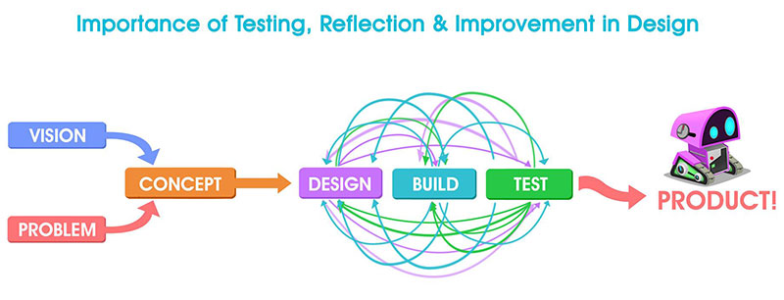
The Design Process reframes errors and improvements as a necessity for deeper learning and permits and encourages the use of many "right" answers.
The activity is interactive, collaborative, and decision-making regarding solutions are based on student reflections. Students collaborate to exchange ideas and carry out any necessary re-designs to their solutions or prototypes in order to create an improved good or service.
And the design process can be used to produce solutions for the
Following typical classroom exercises as well as physical solutions to problems:
How do you craft an engaging story?
How can a football defender improve?
What steps can you take to meet new people?
What might I depict that would make the viewer feel sympathetic?
Note :Answer these question to create the design process.

The Design Process should be used to approach each of the aforementioned challenges:
NOTES TO REMEMBER
The Design Process doesn't follow a strict order, and it could end up solving a problem that wasn't initially thought of.
All learning domains can benefit from the Design Process.
As long as contemplation and taking risks are encouraged and modeled by the classroom teacher, failure is an opportunity to learn.

